

**Jesus Heals a Lame Man by a Pool**

**John 5:1-18**

**Talk About This…**

* What can Jesus do because he’s God?

Jesus goes to a pool where sick people often hang out hoping to be healed by the power of the bubbling water in the pool. One lame man is never able to get there soon enough, so Jesus heals him. The religious leaders get mad, but Jesus is God, and he tells them so.

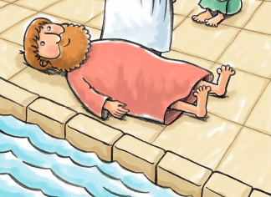

**Through the Week**

* Get everybody to make a sign with his or her name at the top. For example: “Jordan is...”
* Hang the signs.
* Throughout the week, write kind descriptions of each person. For example, “Jordan is...kind, athletic, thoughtful, encouraging.”
* At the end of the week, talk about how you know those things about each other.
* Remind your family that we know who God is because we can see who Jesus is, and Jesus is God.
* Challenge each other to show other people who Jesus is by acting like him.

**Church Announcements**

* [Type your content here]

*“But Jesus replied, ‘My Father is always working, and so am I’ ” (John 5:17).*

